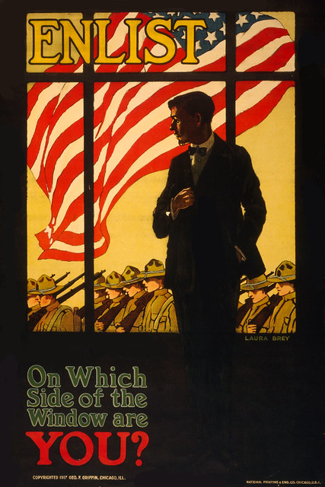

WW1 Project
By Annie Toal

- June 28, 1914
Archduke Francis Ferdinand is assassinated.
- July 28, 1914
Austria-Hungary declares war on Serbia, beginning World War I.
- August 2-7, 1914
Germany invades Luxembourg and Belgium. France invades Alsace. British forces arrive in France. Nations allied against Germany were eventually to include Great Britain, Russia, Italy, Australia, New Zealand, South Africa, Rhodesia, Romania, Greece, France, Belgium, United States, Canada, Serbia, India, Portugal, Montenegro, and Poland.
- August 10, 1914
Austria-Hungary invades Russia.
- September 9, 1914
Allied forces halt German advance into France during First Battle of the Marne.

- February 18, 1915
Germany begins naval blockade of Great Britain.
- April 25, 1915
Allied forces land on the Gallipoli Peninsula of the Ottoman Empire.
- May 7, 1915
German submarine sinks the passenger liner Lusitania during crossing from New York to Liverpool, England, killing 128 Americans.
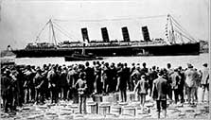

- May 23, 1915
Italy declares war on Austria-Hungary.
- February 21, 1916
Germany begins the attack on Verdun.
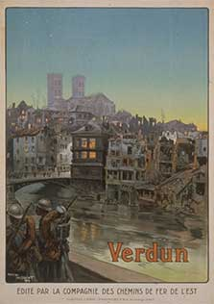
- May 31, 1916
Naval Battle of Jutland takes place between British and German fleets.
- July 1, 1916
Allied offensive begins the Battle of the Somme.
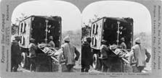

- December 18, 1916
Battle of Verdun ends with 550,000 French and 450,000 German casualties.
- February 1, 1917
Germany returns to unrestricted submarine warfare halted after the sinking of the Lusitania.
- February 3, 1917
United States severs diplomatic relations with Germany.
- April 6, 1917
The United States declares war on Germany.

June 7, 1917
General John J. Pershing, newly selected commander of the American Expeditionary Forces, arrives in England with his staff.
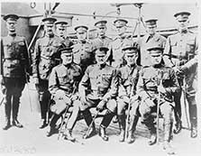
- June 24, 1917
American combat forces arrive in France.
- December 15, 1917
Russia signs armistice with Germany.
- January 8, 1918
President Woodrow Wilson presents to Congress his outline of Fourteen Points required for peace.
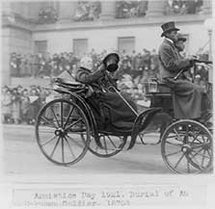
- February 8, 1918
The Stars and Stripes begins publication with a first issue of one thousand copies. Second Lieutenant Guy T. Viskniskki is the first managing editor of the newspaper.
- March 3, 1918
Russia signs the Treaty of Brest-Litovsk with Germany.
- March 21, 1918
Germany begins its final offensive of the war.
- March 1918
American women recruited to serve as bilingual telephone operators for the AEF arrive in Europe.
- May 28, 1918
United States forces are victorious in the Battle of Cantigny, the first independent American operation.

June 2, 1918
American forces stop German attempt to cross the Marne River at Chateau-Thierry.
- July 26, 1918
The Stars and Stripes suspends the Sporting Page.
- September 12, 1918
American First Army attacks St. Mihiel salient.

September 26, 1918
Allied forces begin the attack at Meusse-Argonne, the final offensive of the war.
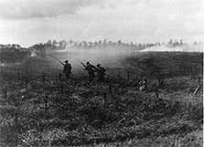

- November 11, 1918
Germany signs the Armistice at Compiègne, ending World War I.
- December 1918
Harold Ross assumes editorship of The Stars and Stripes.
- December 1, 1918
British and American forces enter Germany.
- December 16, 1918
The Stars and Stripes War Orphans Adoption Campaign ends after raising 123,047 francs and placing 3,444 orphans for adoption.
- December 27, 1918
Sporting Page returns to The Stars and Stripes.
- Jan. 18, 1919
Peace conference begins at Paris.
- February 8, 1919
First anniversary of The Stars and Stripes. Circulation surpasses 500,000.
- February 14, 1919
Draft of the covenant of the League of Nations is completed.
- June 13, 1919
Last issue of The Stars and Stripes is published.
- June 28, 1919
Allied and German representatives sign treaty of Versailles. The United States signs treaty of guaranty, pledging to defend France in case of an unprovoked attack by Germany.
- November 19, 1919
United States Senate fails to ratify Treaty of Versailles.

- January 10, 1920
Treaty of Versailles takes effect.
- March 19, 1920
United States Senate fails to ratify Treaty of Versailles for the second time.
- August 24-29, 1921
United States signs separate peace treaties with Germany, Austria, and Hungary.

