World War 1 By Isabelle Doherty

WW1 lasted 4 year, 3months and 14 days.
It started on the 28th of July 1914.
It ended at 11:11 on the 11th of the 11th 1918.
It was also known as The Great War, World War, War of the Nations and The War to End All Wars. That was before the Second World War.

The cause of the war was a few different reasons including the assassination of Franz Ferdinand of Austria and pregnant wife Sophie. He was nephew to the emperor of Austria and was heir to the throne; the assassination was planned by a Serbian terrorist group called the Black Hand, it was Gavrilo Princip who shot. Another cause was the disagreements of foreign policy and wanting territory back.
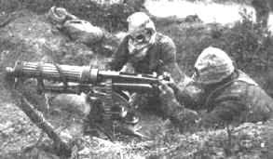

135 countries took part in this war; there were two different groups the allies and the central power. The Allies included Russia, France, The British Empire, Italy, U.S.A, Japan, Romania, Serbia, Greece, Portugal and Montenegro. The Central Power Included Germany, Austria, Hungary, Turkey and Bulgaria. 8 million soldiers died and 21 million were injured. 58000 British soldiers lost their lives in the first day. 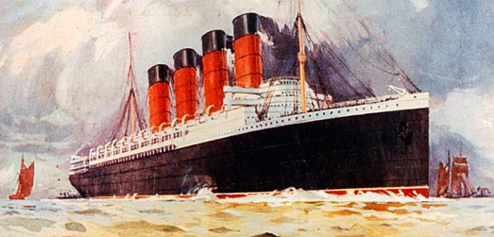
Lusitania was sunk by a German submarine, 1195 passengers lost their lives. 128 were Americans so the pressure was on the U.S government to join the war. On the 6th of April 1917 President Woodrow Wilson of America wanted to restore peace in Europe, so he decided to let America join the war.
65 million troops were mobilized during the war and chemical weapons were first

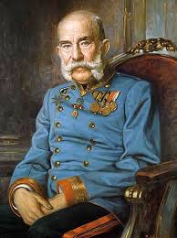Franz Josef

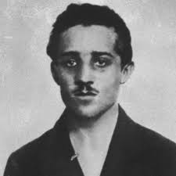 Garvilo Princip
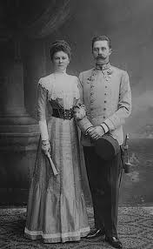 Franz Ferdinand & Sophie
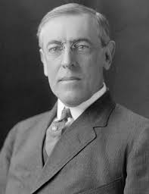 Woodrow Wilson
